به نام خدا

پیش گزارش آزمایش 5

بردیا برائی نژاد(92101669)

1.

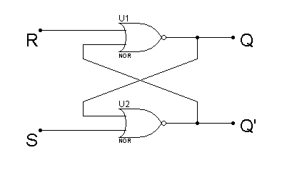

2.

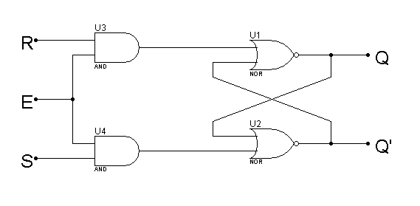

3.

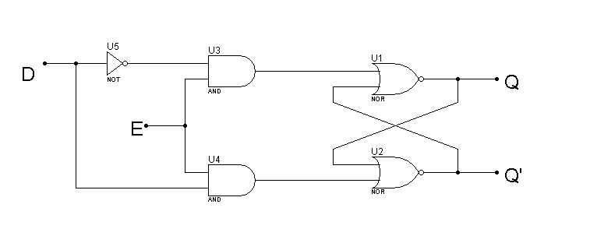

4.

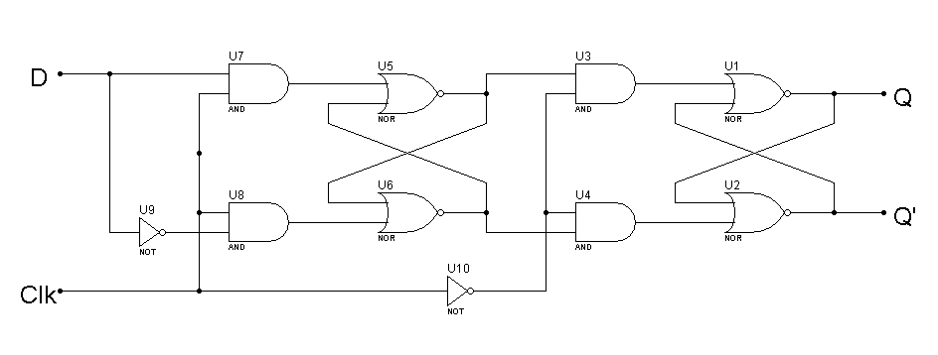



5.



|  |  |  |  |  |  |
| --- | --- | --- | --- | --- | --- |
| R | S | Q’ | Q | K | J |
| 0 | 0 | 0 | 0 | 0 | 0 |
| 0 | 0 | 1 | 1 | 0 | 0 |
| 0 | 0 | 0 | 0 | 1 | 0 |
| 1 | 0 | 0 | 1 | 1 | 0 |
| 0 | 1 | 1 | 0 | 0 | 1 |
| 0 | 0 | 1 | 1 | 0 | 1 |
| 0 | 1 | 1 | 0 | 1 | 1 |
| 1 | 0 | 0 | 1 | 1 | 1 |

7.